**User Acceptance Testing for Fishyfeeder:**

UAT is the process of verifying that the system works for the user.

UAT is the last phase of the software testing process. During UAT, actual users test the software to ensure that it can handle the required tasks in real world scenarios.

To begin, I typed in the URL to our website and ensured that it ran as intended on several different browsers.

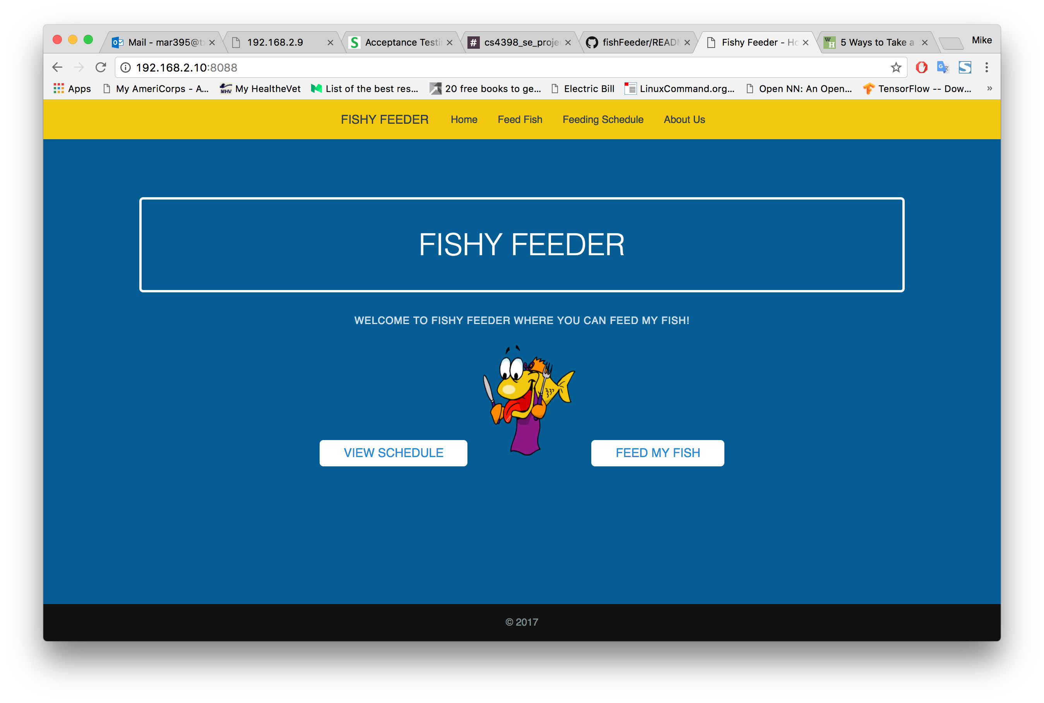

Figure 1: Fishyfeeder website running in Chrome

The goal of UAT is to ensure that your finished product is suitable to the customer and matches all of his or her needs. So once the website was loaded, I clicked through all the links and made sure that they were 100% working.

Starting at the top bar, I clicked through all the links ‘FISHY FEEDER’, ‘Home’, ‘Feed Fish’, ‘Feeding Schedule’, and ‘About Us’.

On every page, the link loaded as intended. I could view a live stream of the fish, I could check its last feeding time and I could even send as message to the creators of the website to tell them how much I enjoyed watching the fish.

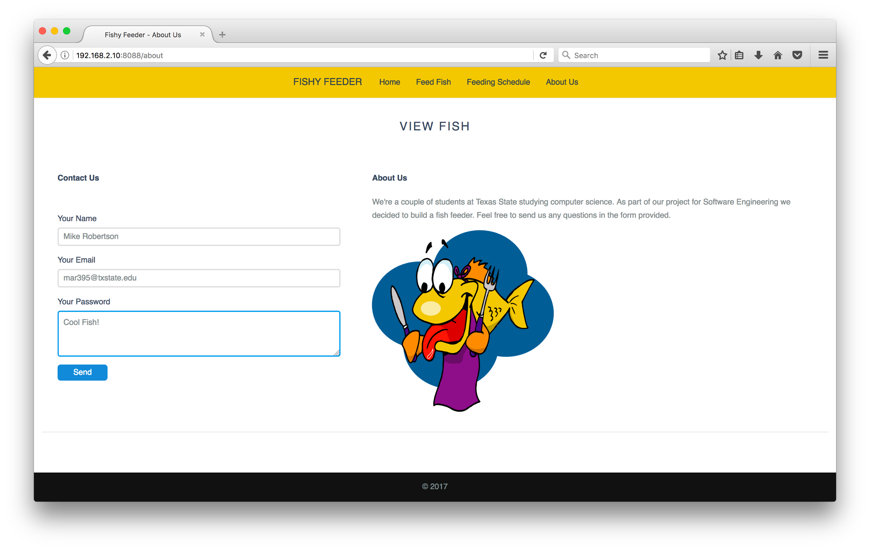

Figure 2: Entering input on the 'About Us' page

Compatibility across different browsers is obviously important as well. Not all clients use the standard ‘Safari’ or ‘Internet Explorer’ So it is essential to test if our website works across platforms. The website works correctly in mobile as well. Though it is not optimized and looks much better in landscape mode. The links become crowded a little too much in portrait mode. This is something that would be easy to optimize.

It is recommended that as system meets 10 requirements to ensure that it is ready for UAT. I believe that our system meets all these requirements.

1. Business requirements must be available.
2. Application code is fully developed
3. All testing complete
4. No ‘show stoppers’ – we have obvious bugs or flaws
5. Only cosmetic errors are acceptable
   1. The landscape/portrait cosmetic defect I mentioned earlier is an example of this
6. Regression testing completed with no major defects
7. All reported defects have been reported and tested
8. Traceability matrix completed, all links work as intended
9. UAT environment is ready
   1. We displayed a working example in class on April 25
10. Our team confirmed that system was ready for UAT

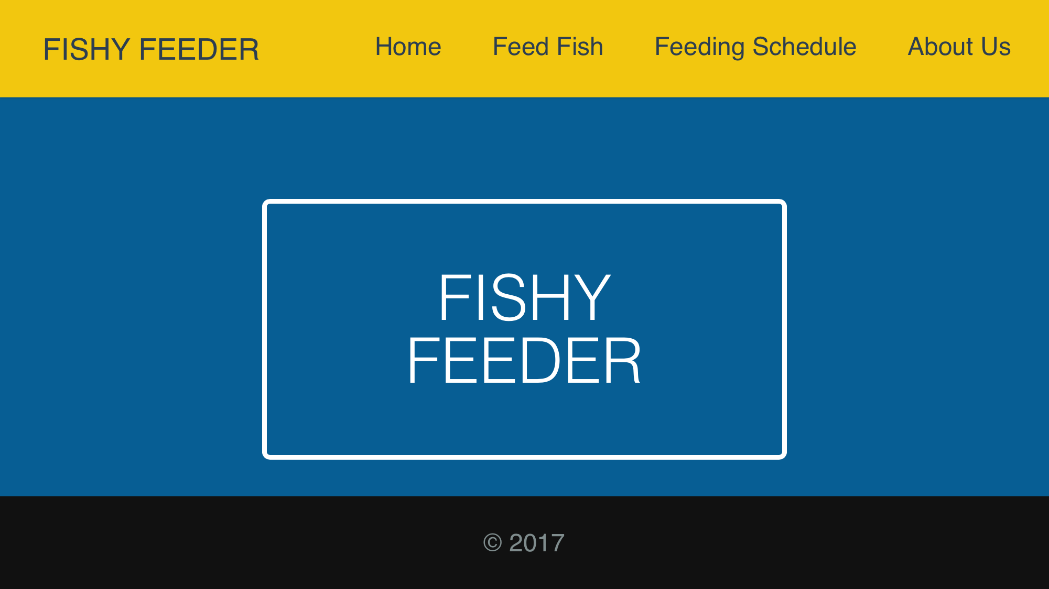

Figure 3: Fishy Feeder in Safari on mobile phone

We need to ask four questions are part of our UAT to ensure that it is successful

1. Can the user use the software?
   1. The end user can easily use the fishy feeder software. The website is up and running smoothly.
2. Is it really what they asked for?
   1. Yes, this is exactly what the user asked for. A mobile solution to feeding and viewing their fish.
3. Do they have trouble using it?
   1. No problems were identified during this iteration of UAT.
4. Does it behave exactly as anticipated.
   1. The links lead to where they are supposed to lead, and all parts of the website work as intended.

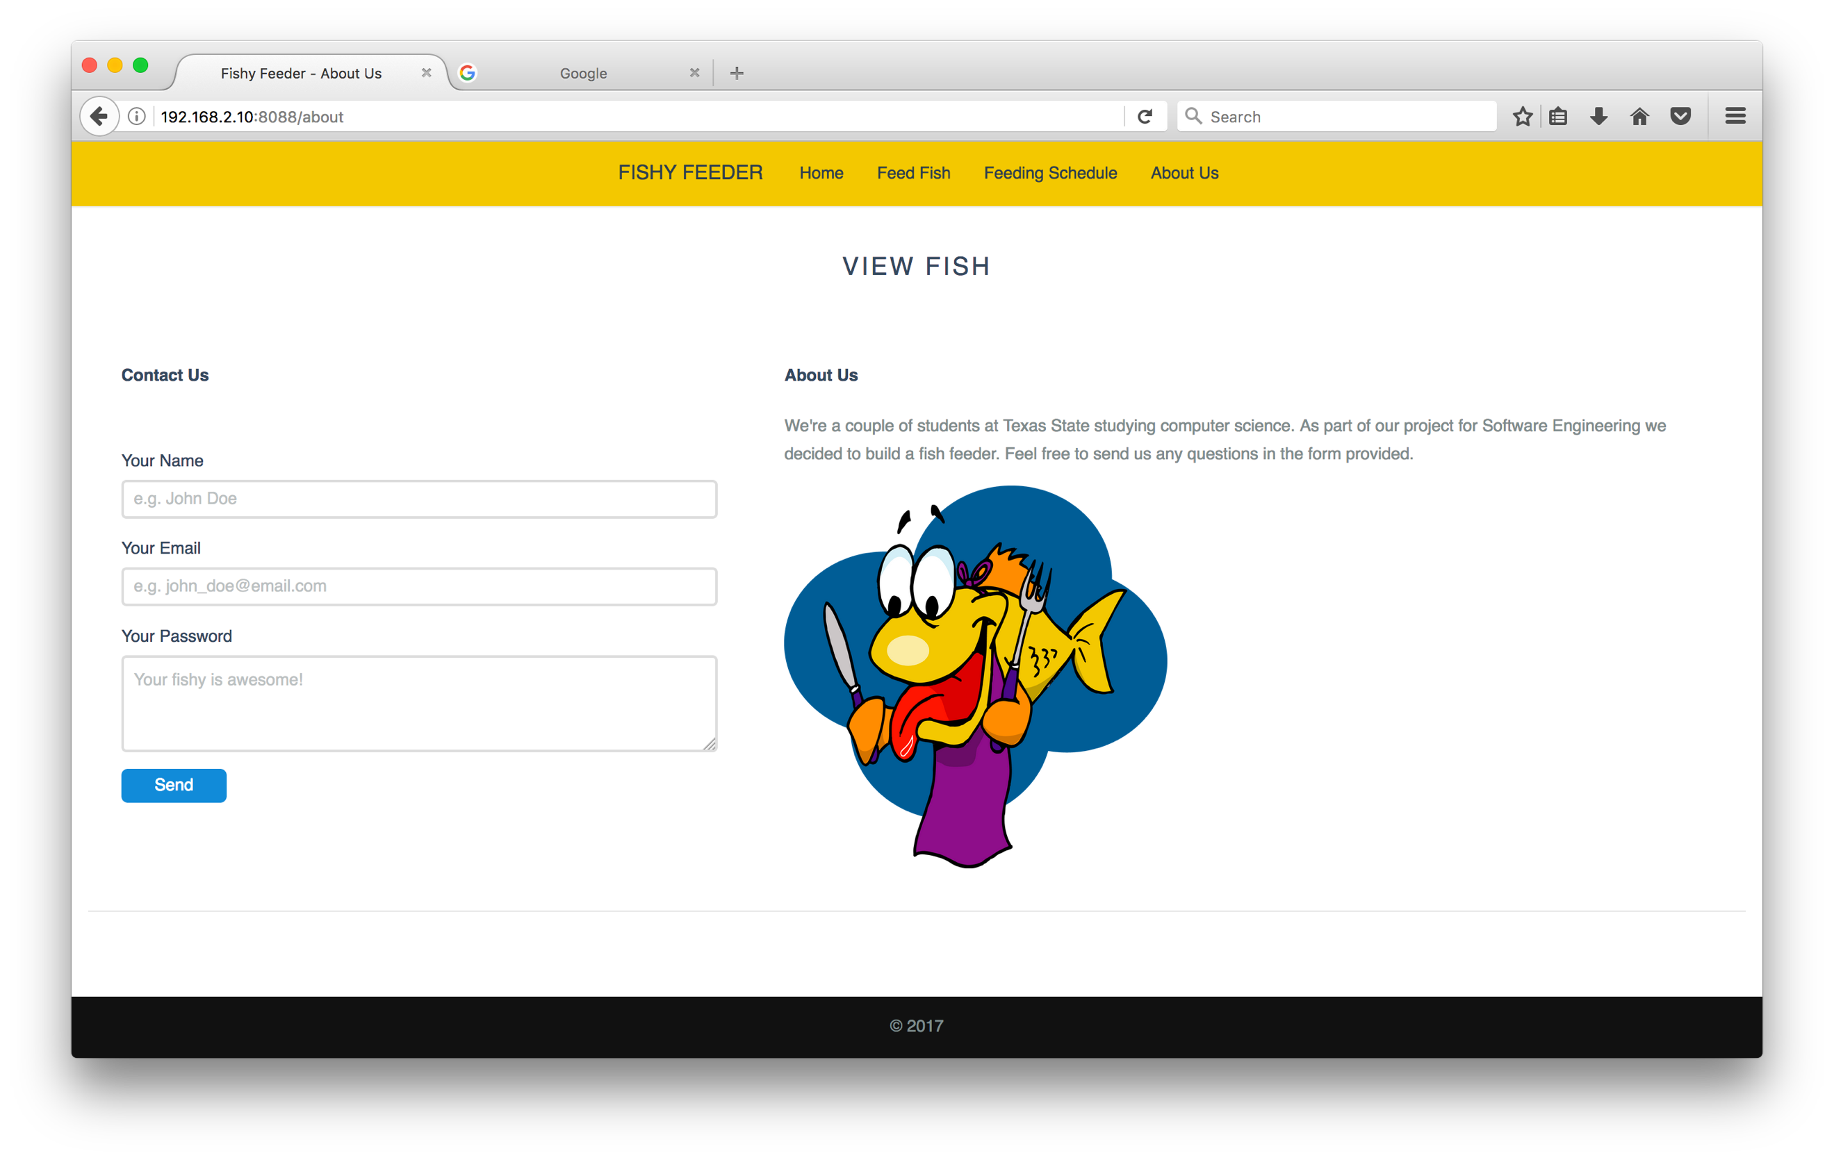

Figure 4: Fishy feeder website running in Firefox

References:

https://usersnap.com/blog/user-acceptance-testing-right/